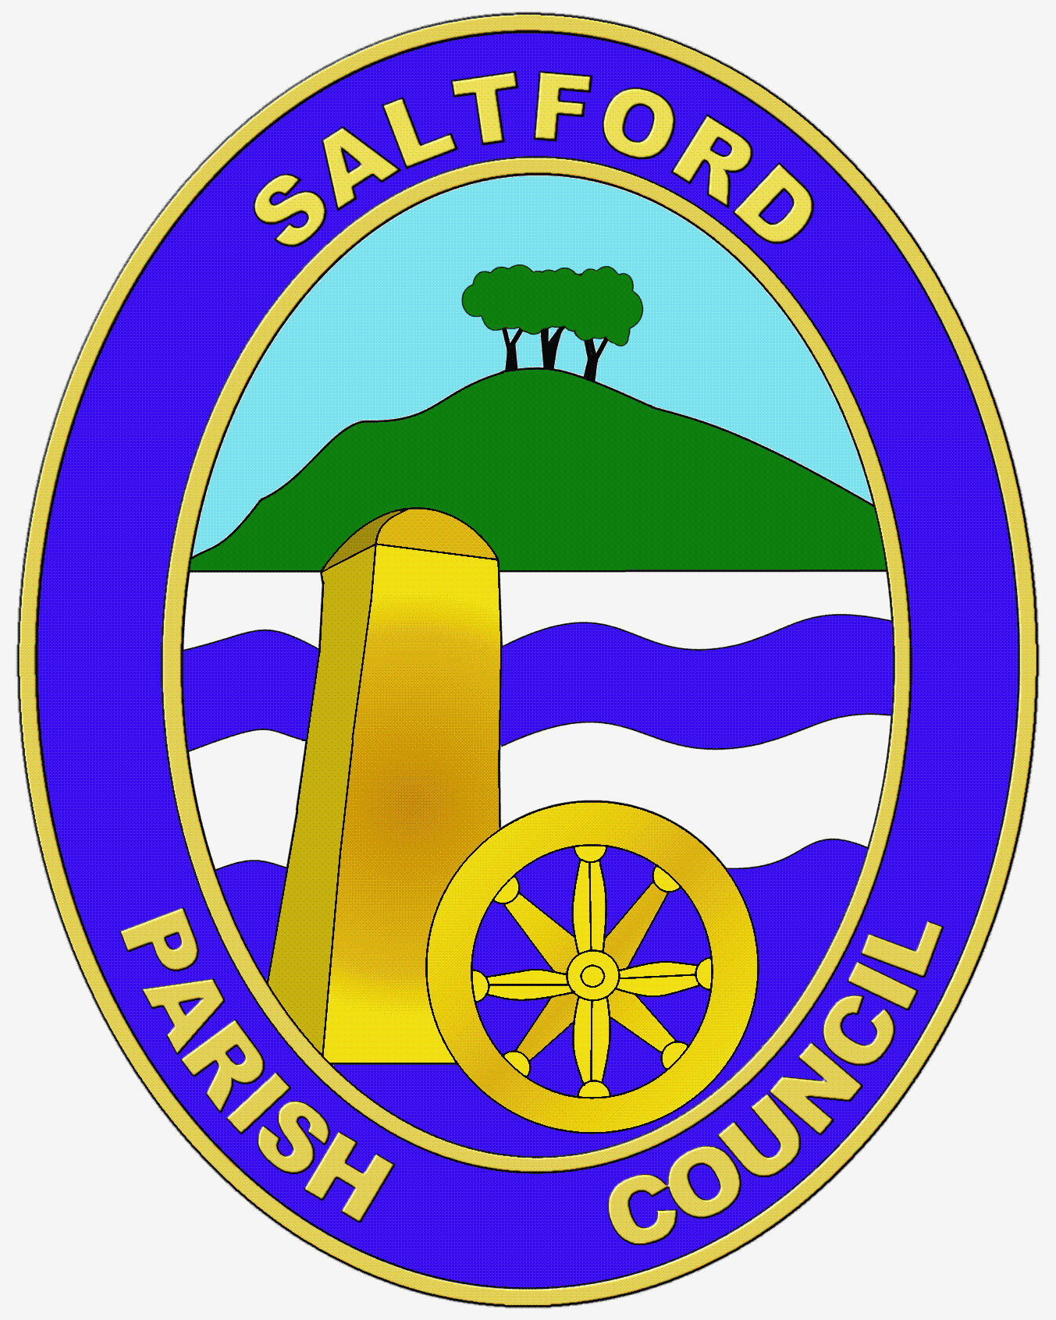

Saltford parish council

COMMUNITY AWARDS NOMINATION FORM 2020

Categories:
- Young Person of the Year in Saltford Award
- Volunteer Team of the Year in Saltford Award
- Saltford – Achievement Award
- Business in the Community Award

Criterion:
Awards are given for an outstanding contribution, performance or commitment to Saltford.
All awards are to recognise those individuals and groups that have made and are making a positive contribution to Saltford life, and are showing leadership, initiative or commitment in the local community. The business in the community award is to recognise a socially responsible business which actively supports the local community in positive activities.

Which of the above categories of award is your nomination for?

About you:

Your name:

Your address:
Your telephone number and email address (if you have one):
About your nomination:

Which person, group or business are you nominating? Name of person, group or business:

Contact details for this person, group or business:

Your reasons for nominating this person, group or business for this award:

Please provide as much information as possible on how the person, group or business you have nominated has contributed to the community of Saltford in the category chosen by you. You can refer to achievements, projects, a difference that has been made, engagement with neighbours & residents, the skills and experience of the person or group, challenges met or initiatives taken (please continue on additional sheets if required).

The ‘SPC Community Awards – Criteria and Process’ document is available at www.saltfordparishcouncil.gov.uk.

Please send this nomination form and supporting information by the end of Friday 7th February 2020 to the Parish Clerk, by email to clerk@saltfordparishcouncil.gov.uk or at Saltford Parish Council Office, Saltford Library, 478a Bath Road, Saltford BS31 3DJ.

