Saltford parish council
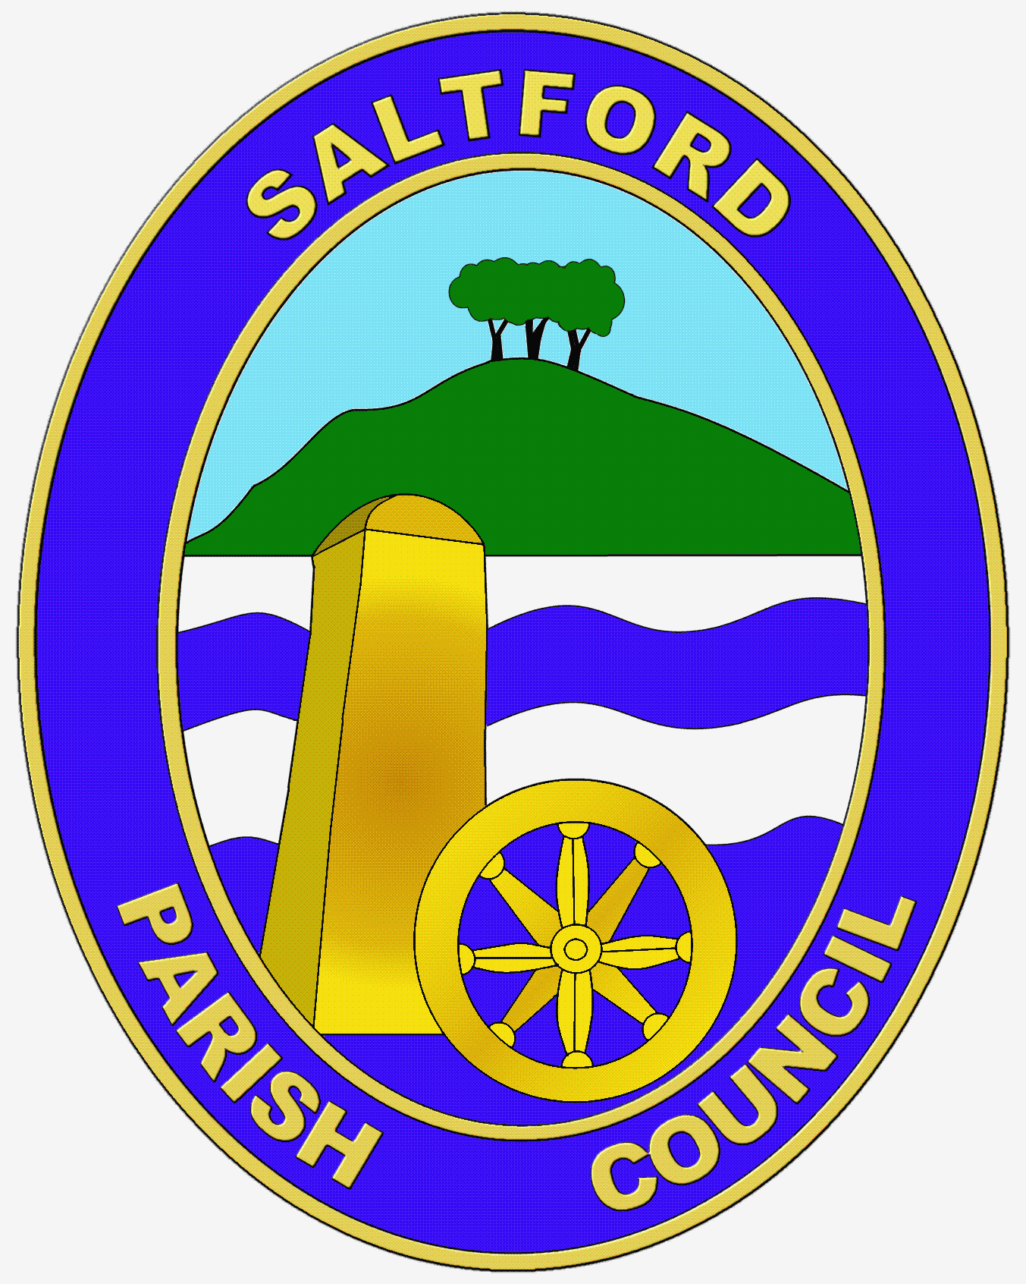

grant application Form

Applications must be submitted to the Parish Clerk. For an application to be considered, this form must be accompanied by the latest set of annual accounts and a copy of your organisations written constitution or your aims and purposes. Please read the Grant Application Guide and Grant Application Policy at www.saltfordparishcouncil.gov.uk prior to making an application.

Name of organisation making the application:
Short description of the organisation:
Name, address and status of contact:
E-mail address of contact:
Telephone number of contact:
Is the organisation a registered charity? | Yes / No If applicable please provide charity no.
Amount of grant requested: | £
Break down of grant requested (if applicable)
Describe what the grant is for:
Who will benefit from the project?
Approximately how many of those who will benefit are residents of Saltford
If the total cost of the project is more than the grant, how will the rest be financed?
Have you applied to any other body for a grant for the same project? If yes, please give details:
Signature and date:

Please attach any other information which you feel will support this application. Please return the completed form to Lottie Smith-Collins, Parish Clerk at clerk@saltfordparishcouncil.gov.uk or Parish Office, Saltford Library, 478a Bath Road, Saltford, Bristol BS31 3DJ

